Assignment 3 - Usability Testing

Chloe Youzhi Wu

W209 Spring 2020

# Background

Our website consists of three sections:

* **Overview**: this section presents an overview of our project objectives, the goal of our website, as well as overall visualization of WASH coverage in five pillars. For context, WASH consists of five pillars as defined below:
  + **Basic water** source within 30mins roundtrip
  + **Safely managed water supply** at home: continuous and safely managed water
  + **Handwashing station** with soap and water at home
  + **Any fixed point defecation**: to prevent open defecation and provide a facility that safely separates human waste from human contact
  + **Safely managed fecal sludge**: emptying pits of faecal matter and transporting the sludge to treatment and disposal
* **Story**: this section consists of five storylines, each corresponding to one of the five WASH pillars.
* **How to help**: this section provides information about where investment can do the most good.

The three testers participated in our testing sessions separately via Zoom meeting. During the testing sessions, we walked through the questions on the task list. After each section, we asked testers to provide their feedback on a Likert scale survey. At the end, testers provided their general feedback.

# Notes on User Testing

Observations on each tester’s behavior are logged for each task question.

* Text in black color is the task question;
* Text in blue color are notes on user testing.

## Overview Section

1. Which WASH pillar has the lowest coverage? What about the highest?

* All three testers had no problem finding the overall coverage rate for each WASH pillar, and were able to identify the lowest and highest pillar quickly.
* Tester 3 commented that there was a learning curve on how to use the UI, i.e. controlling scroll bar within Tableau window and scroll bar on the web page.

1. Find the Handwashing station percentage for a country in Africa?

* Tester 1 did not know that he could click on different tabs on a storyline. For him, the tab is in grey color with long descriptive text which made him think that it was just annotations to the data visualizations.
* Tester 2 also commented that the storypoint tab was not obviously clear to be clickable.
* All three testers noted one issue on the visualization where the user can filter by Region and Country, where the Country dropdown selection filter would not update automatically according to Region filter selection.

1. Why do you think some countries aren’t on the map?

* Tester 1 thought it was because no data was provided. Although it is partially corrected, the main idea for this question is to ensure users understand that only data for 140 developing countries are presented.
* Tester 2 thought that it was because the other countries had reached full coverage. It indicated that the background of our dataset was not introduced clearly to users.
* Tester 3 found the information in the caption of a story point.

1. For the Middle East & Africa region, which pillar has the worst rating?

* Tester 1 had no issue identifying the pillar with the worst rating. However, he found out that the coverage rates were not consistent across tabs, i.e. 26% in the first tab, and 28% in the third tab. One minor issue found by the tester was that there was “null” selection in the dropdown filters in the third tab.
* Tester 2 had no issue identifying the pillar with the worst rating.
* Tester 3 was able to find the information on the third tab.

1. Are you able to pull up the story that correlates to Basic Water?

* Tester 1 was able to navigate to the “Story” section and open up the “Basic Water” storyline. However, he did not complete the task quickly.
* Tester 2 was able to navigate to the “Basic Water Story” without any assistance.
* For Tester 3, the navigation was quite straightforward.

## Story - **Basic Water Section**

1. Identify regions with below average access to basic water?

* Tester 1 had no issue identifying regions with below average access to basic water.
* For Tester 2, the task was easy. But she needed to scroll down the pop up window to see the full picture. The UI is designed as a pop-up window with Tableau visualization embedded, which results in several scroll bars for users to control. It poses a certain learning curve for first-time users.
* Tester 3 was able to identify the regions but the scroll bar became a bigger issue for her.

1. Identify the region with the highest levels of basic water coverage? The lowest?

* Tester 1 had no issue identifying regions with highest coverage and the one with lowest. Tester 1 also found other issues non-related to the task, such as
  + His biggest comment was that the text for each tab was too long which made him feel that it was not a clickable link.
  + The bar charts were not sorted which made it hard for the user to quickly get valuable insight out from the visualization.
  + He didn’t understand the scatter plots. He commented that if we wanted to keep the scatterplots, we needed to add some highlights so as to convey a key idea to users.
* Tester 2 was able to complete the task without any issue.
* Tester 3 found the information on the story point caption rather than in the data visualization. This could be because of the scroll bar issue that she did not know she could scroll down to get the information.

## Story - **Any Fixed Point Defecation Section**

1. How many people in the world were practicing open defecation in 2015?

* Tester 1 was able to quickly find the number of people in the first tab.
* Tester 2 was able to find the number. In addition, she commented that “global coverage” was misleading, which made her think that it was for all countries, but just developing countries.
* Tester 3 was able to quickly find the number of people in the first tab.

1. Which country in the Middle East & Africa region had the lowest coverage?

* Tester 1 was able to quickly identify the country in the third tab by filtering Region with Middle East & Africa selection, and looking at the sorted bar chart. His additional comment was that the linear regression plot may not be needed.
* Tester 2 was able to find the country. But she noted that the map view and the bar chart were not connected to each other, that is, filtering on one graph did not reflect on the other graph, i.e. clicking on Eritrea on the bar chart did not show the country on the map.
* Tester 3 was able to quickly identify the country.

## Story - Handwashing Station Section

1. What is the difference in handwashing coverage between rural and urban regions? In which region is the gap largest?

* For Tester 1, the task was challenging, because the y axis title was too long and did not show “rural”. Also for this graph, the top plot displayed values in % but the bottom one displayed values in decimal.
* Tester 2 also noticed that the y axis of the top bar chart did not display “rural” text because its naming was too long. She guessed from the fact that the bottom one showed “urban”. She commented that the gap needed to be calculated by hand which was hard for her to get. She had a question as to why the color for Asia Pacific region was highlighted in dark blue color whereas the others were in light blue color.
* Tester 3 could only guess that the top bar chart was for rural. She needed to do calculations to get the answer.

1. Which region has the greatest amount of population that does not have access to hand washing stations?

* Tester 1 was not able to find the information. He could only find the coverage rate for each region. He also noticed that the map view was not centered. He did not know how to move the map. Tester 1 noted that two tabs on this section were showing captions as “TBD”.
* Tester 2 was not sure how to answer this question. She guessed it would be Asia Pacific based on the fact that it is highlighted in dark blue color. She also commented that the fonts on this storyline were not consistent.
* Tester 3 found the coverage rate but not the population. She commented that the logical links between the story points seemed to be weak. It would be better if all storylines were to follow the same sequence so that users would not have a learning curve for each storyline.

## Story - Safely Managed Water Section

1. How many people don’t have access to safely managed water?

* Tester 1 could not find corresponding information. There is no information on the number of people without access to safely managed water.
* Tester 2 could not find the information. She commented that it was very hard to find.
* Tester 3 could not find the information.

1. Describe the relationship between GDP and safely managed water coverage rates

* Tester 1 responded that the relationship seemed flat and no correlation. Also he noted that the GDP scatter plot was not showing the correlation between GDP and coverage rate but was showing GDP and cost per capita. He guessed it was plotted in mistake.
* Tester 2 noted that the scatter plot was not showing the relationship between GDP and coverage rate, but rather it was showing GDP vs. cost per capita. She concluded that she could not answer this question.
* Tester 3 could not find the information from the visualizations but found it from the caption.

## Story - Safely Managed Fecal Sludge Section

1. Find a country with less than 20% fecal sludge coverage rates?

* Tester 1 clicked through each tab on this storyline, and was able to find the countries with less than 20% coverage rate. He commented that annotating Peru as “unexpected” and Belarus as “ignored” may be too subjective.
* Tester 2 was able to find the information quickly.
* Tester 3 was able to find the information. But in general, she thought that the text for all storypoint tabs seemed to be too long that she almost did not know to click next. The tester noted that somehow the coverage % for Belarus did not show on the bar chart.

1. Which country has the lowest cost per person to implement full coverage?

* Tester 1 could not find the information. The information is buried deep in the scatterplot in the final tab. It is not a key message that the visualization would like to convey.
* Tester 2 found Tajikistan which is the country with the lowest cost per person within the highlighted set but not the entire set. Users may easily just put their focus on what is highlighted to them.
* Tester 3 first tried to find the information from the map based on color. But since the color scale was close, she could not find it from map view. She was then able to identify the lowest country within those were highlighted on the scatterplot.

1. List two countries that may have high returns on investment?

* Tester 1 was able to find a list of countries that may have high returns on investment. The graph highlighted the countries so it was easy for him.
* Tester 2 quickly got the list of countries as they were highlighted in color and annotated with text.
* Tester 3 had no issue finding the information.

## How to Help Section

1. For providing basic hygiene what percentage of spending would go towards capital? Operations?

* Tester 1 was not able to identify “Basic Hygiene”. When the question was reframed to “Basic Water”, he was able to filter the visualization and knew he could get the results by adding up the values on the bar charts. The bar charts divide capital and operation spending into rural and urban, so some hand calculation is needed.
* For Tester 2, she did not know to click on the “Type” drop down list to filter pillars as she did not relate them together. In addition, she commented that the bar chart did not show % numbers which made it hard for users to get an exact value. Because the spending on capital and operation categories were divided by urban and rural, she had to add them up manually to answer this question.
* For Tester 3, in addition to the challenges occurred to Tester 1 and 2, the scroll was an issue. As she scrolled down the webpage, if her mouse was on the map, it would zoom in/out of the map. She recommended changing “Type” to “Five Pillar”.

1. Find the WASH measure with the lowest operational costs?

* Tester 1 did not know, because he needed to filter the five pillars one by one and then add up all operational costs.
* Tester 2 found it impossible to find. She commented that it was because that the scale of its y axis was dynamically changing, there was no direct and visual comparison of how large the cost was among different pillars.
* Tester 3 ran into the same challenges as Tester 1 and 2.

1. Select a country - how many people would $1000 provide access to water to?

* For Tester 1, the task was easy.
* Tester 2 was able to quickly find the number of people.
* Tester 3 was able to quickly find the number of people.

1. Which country could you help the most people with $1000?

* Tester 1 quickly found that the country was Georgia.
* Tester 2 was able to quickly answer this question correctly.
* Tester 3 had no issue answering this question. But she noted that the pillar filter was always reset to “basic water”.

1. Find a country where 1000 would help no one.

* Tester 1 was not able to find this information. By sorting the bar charts in a reversed order, he would be able to find the answer. However, it may be because he had never used Tableau before and thus he did not know that he could sort the bar charts.
* Tester 2 found out that the ranking bar chart could be sorted in reversed order so she was able to answer this question. She commented that the Tableau sorting feature was not obvious for first time users. Additionally, she noted that the Country column name had “1.” at the beginning.
* Tester 3 found out the country by reversing the ranking. She found the sorting even though she has not used Tableau before.

## Debriefing Questions

1. What was your favorite thing about the site?

* Tester 1 liked the UI the most. For him it was very clean and organized.
* Tester 2 thought that the UI was clean. She also noted that the icon color for each pillar color actually corresponded to the overview bar chart.
* Tester 3 liked dynamic interactions on our visualization. She also liked the donation part.

1. What was your least favorite thing about the site?

* Tester 1 did not like the caption text of each story point as they were too long. Another aspect would be that the linear regression plots seemed unnecessary as they did not reveal any internal correlation.
* Tester 2 did not like the pop up window. It was not easy for her to control because there were a couple of scroll bars. She would prefer it just to open a page. She also thought that there was too much text in the caption. It'd be better to make it shorter and easier to locate. Finally, she recommended that it would be better to make the story points for each storyline in consistent order.
* Tester 3’s biggest issue was zooming in and out with scrolling as she had a small screen. Besides, the story points are not strongly connected with each other logically. Since different people would have different logics, it may help to make all storylines consistent.

1. What was missing from the site that you were expecting to see?

* Tester 1 commented that the website provided sufficient information, and explored all major aspects.
* Tester 2 wanted to know how many people had been helped since the SDG was established.
* Tester 3 would like to know about how the donation money would be used.

## Likert Scale Survey Results

Our Likerst scale survey is located here: <https://berkeley.qualtrics.com/jfe/form/SV_bO4VsYy3WzLm0oR>

There are in total 10 questions. The responses to each of the 10 questions are visualized below.

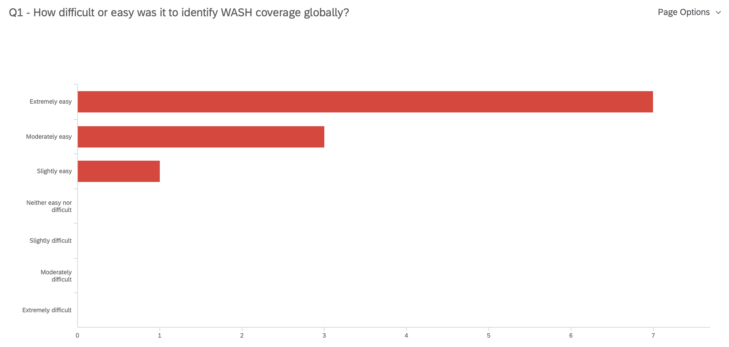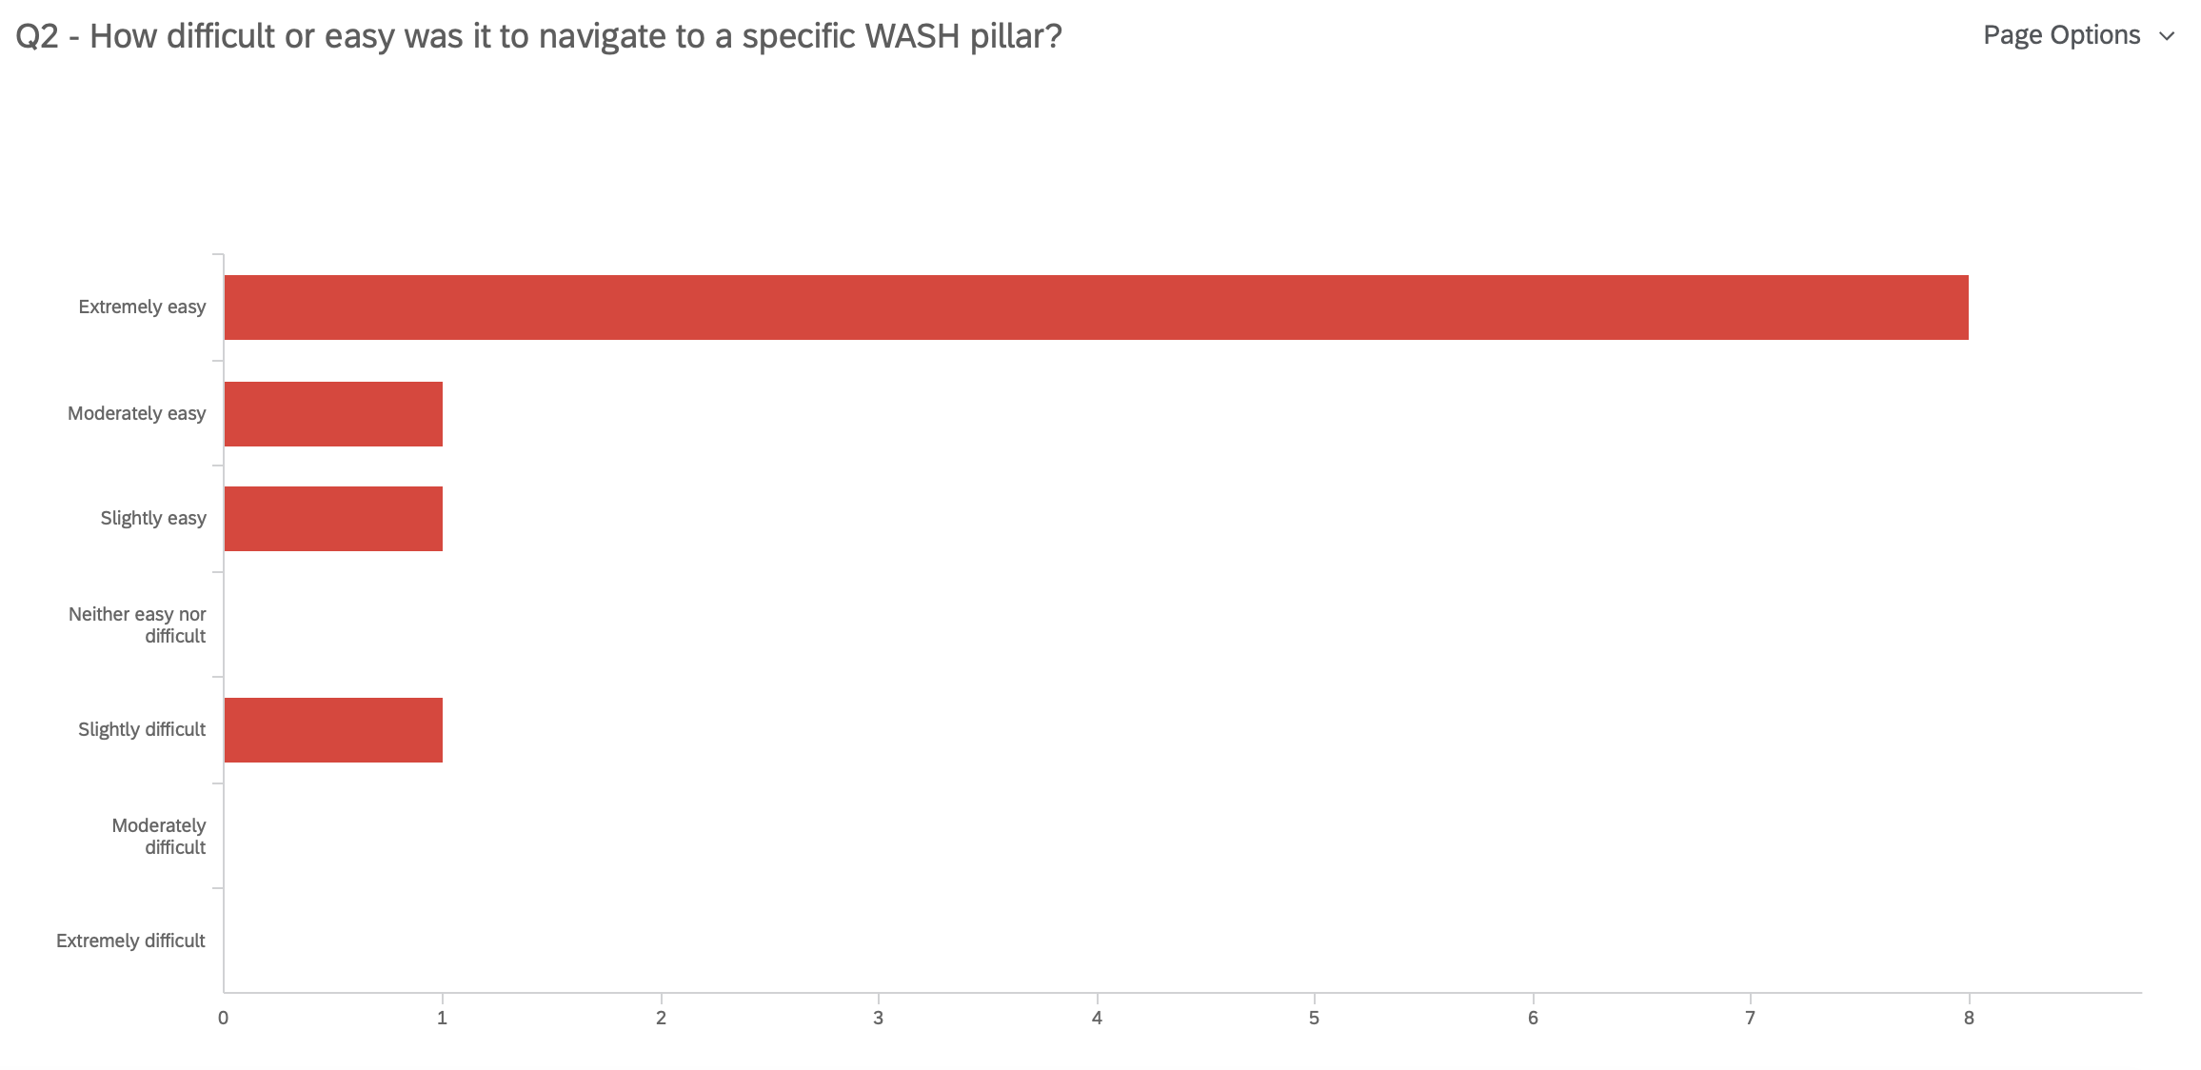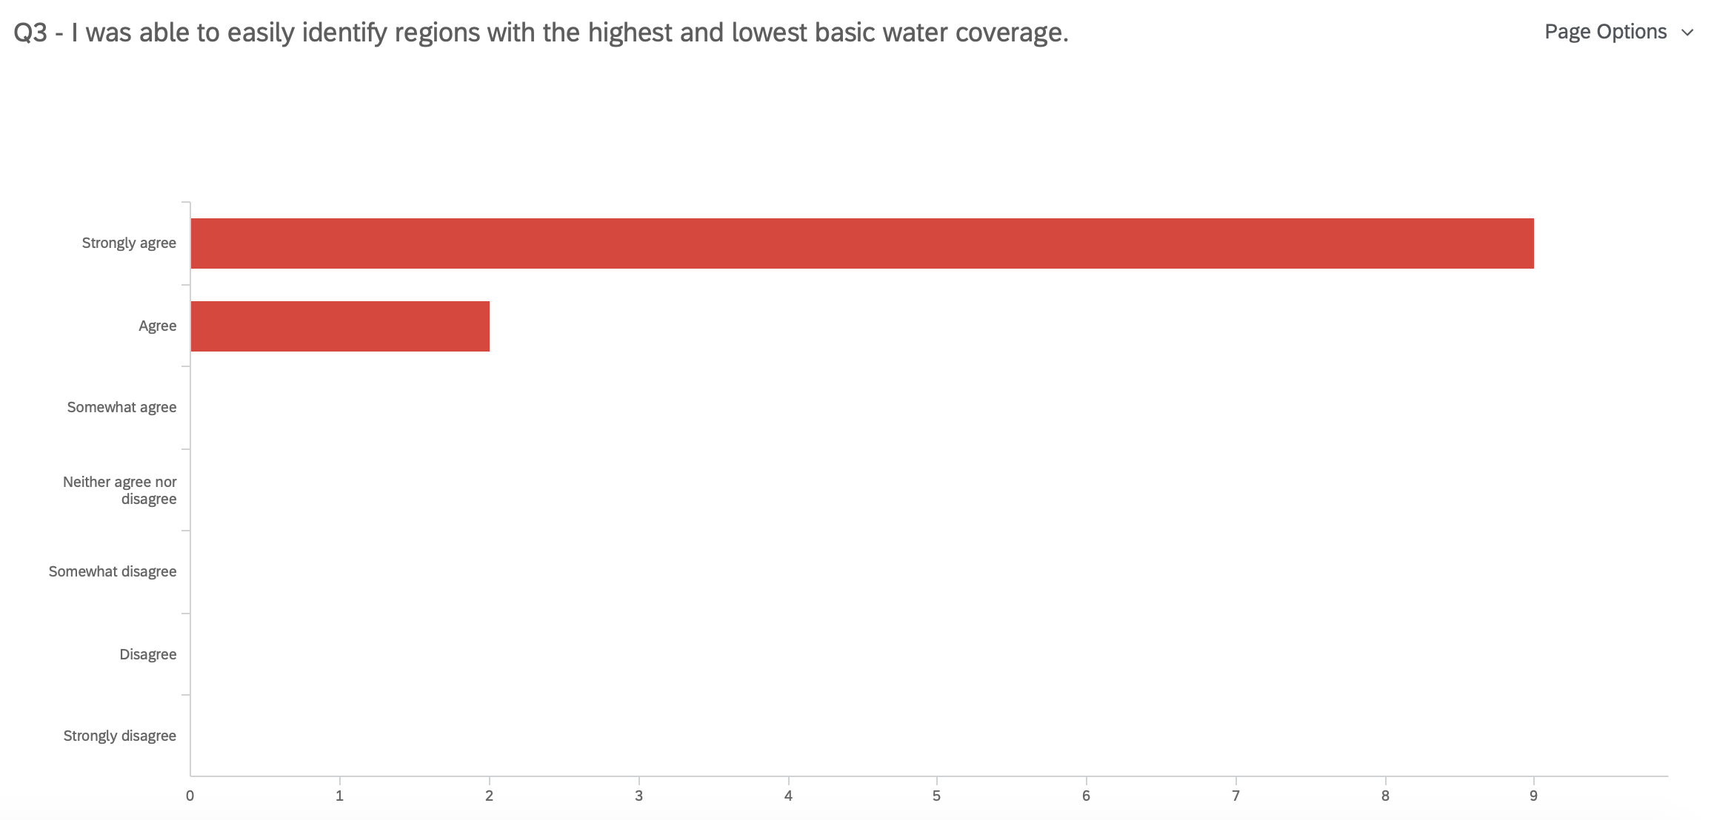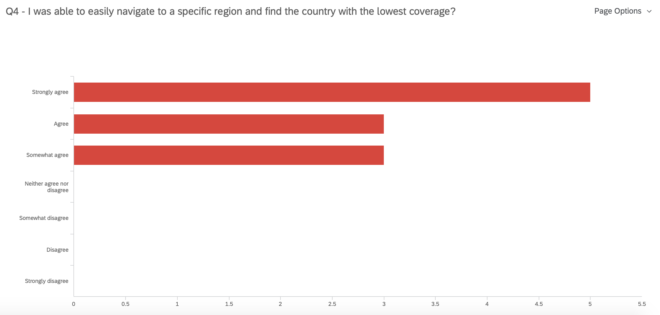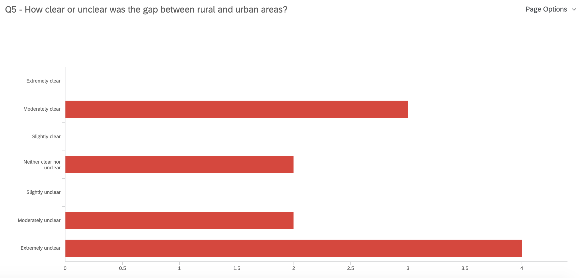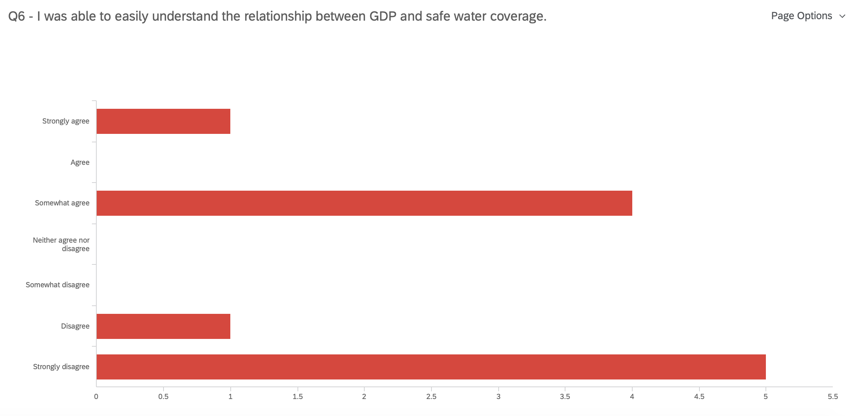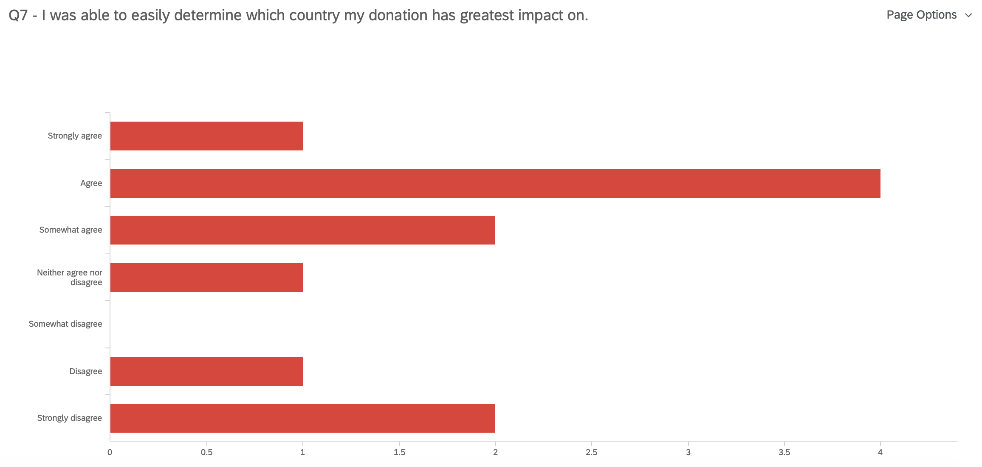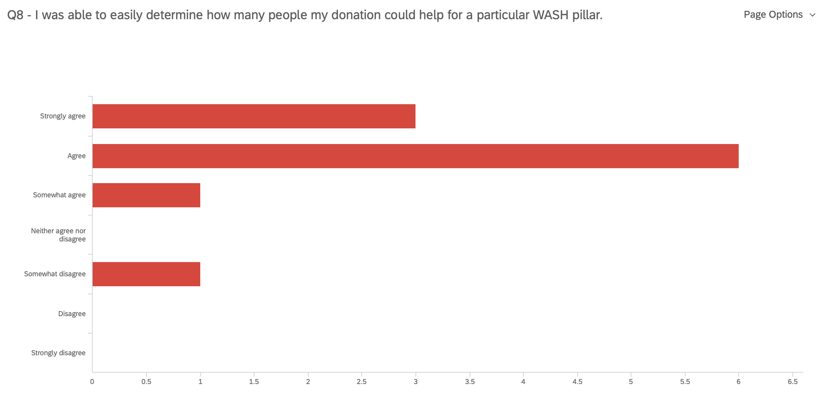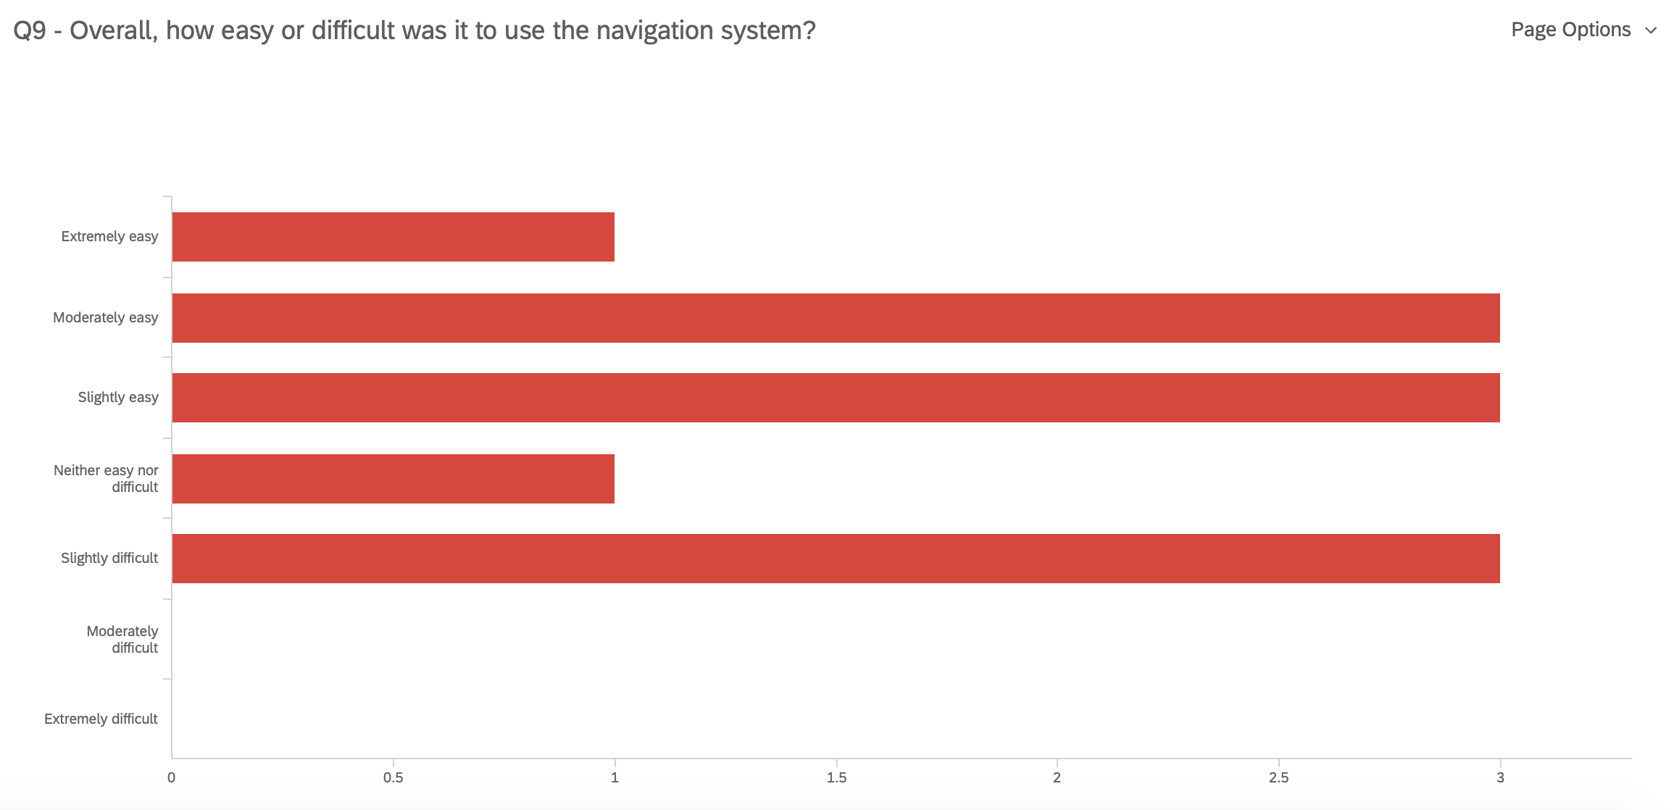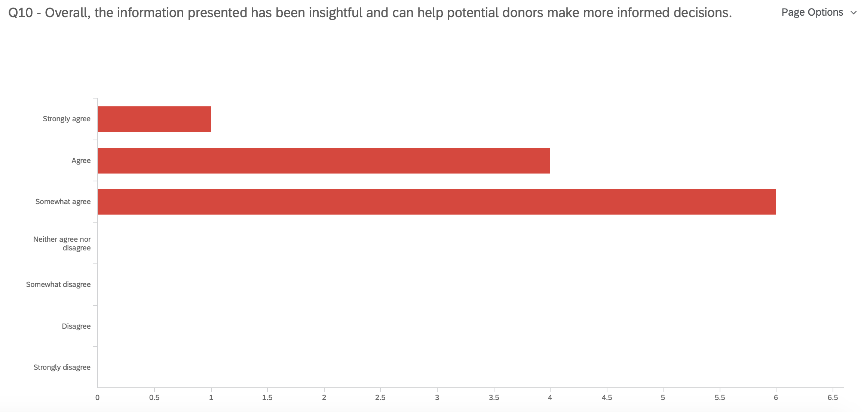

From the above results, we conclude that our website is good at providing overview visualizations. However, in terms of more insightful visualizations, our ideas are not clearly conveyed to users which results in different interpretations of our key messages. As of our next step to finalize our prototype, we should focus on the correlations between GDP and coverage, the difference in rural and urban areas, and how your donations can help.

# Prioritized List

## Must-Have

|  |  |
| --- | --- |
| **Issues To Be Addressed** | **Potential Solution** |
| Captions for story point tabs are too long. | Make all captions to be short and concise. |
| Region and Country filters are not connected. So if selected a country and a region at the same time, but the country is not within the region, there will be no data presented. | Link Region and Country filters so that when a region filter is selected, the country filter selection will be refreshed accordingly. |
| Coverage rates are not consistent across tabs. | Go through the queries to make sure they are consistent. |
| Bar charts on the overview section are not sorted. | All bar charts will be sorted so that it is easier for users to locate the top / bottom one. |
| Map view and the bar chart on the fixed point defecation section are not connected to each other, that is, filtering on one graph did not reflect on the other graph. | Link the two graphs so that filtering on one graph would reflect on the other one. |
| The y axis title for “Rural vs. Urban” graph is too long and does not show “rural”. | Go through all graph axis labels/titles to ensure that all text is visible to users. |
| On the “Rural vs. Urban” graph, the top plot displays values in % but the bottom one displays values in decimal. | Change the value formats so that they are displayed in consistent format. |
| Two tabs on the handwashing section are showing captions as “TBD”. | Add captions to the two tabs. |
| There is no information on the number of people without access to safely managed water. | Add a story point to the safely managed water storyline to show the number of people without access. |
| Default map view is not centered. | Reset the map view and then republish Tableau story so that the default view is centered. |
| The fonts on the safely managed water storyline are not consistent. | All text needs to be in consistent font. The font used in our visualization would be Tableau Book. |
| The GDP scatter plot in the safe water section is not showing the correlation between GDP and coverage rate but instead showing GDP vs. cost per capita. | Change the scatter plot x axis to be coverage rate instead of cost per capita. |
| Testers did not know to click on the “Type” drop down list to filter pillars. | Change dropdown filter name from “Type” to “Five Pillar”. |
| On the how to help section, the bar chart does not show % numbers which makes it hard for users to get an exact value. | Display values for each bar on the bar chart. |
| Country column name had “1.” at the beginning. | Fix the naming of this column. |

## Should-Have

|  |  |
| --- | --- |
| **Issues To Be Addressed** | **Potential Solution** |
| Testers had trouble understanding the linear regression scatter plots between GDP vs. coverage rate, as they are not strongly correlated. | Consider removing the plots because they do not reveal any strong underlying correlations. |
| On the handwashing section, the gap between rural and urban is not presented directly to users. Testers needed to calculate manually. | * Present a grand difference in coverage between rural and urban for all regions; * Change the current bar chart to be a side-by-side bar chart: each region would have two bars, one for rural and the other for urban. |
| The Asia Pacific region was highlighted in dark blue color whereas the others were in light blue color. | The color scale is confusing as it is encoding the number of populations, whereas the entire bar chart is presenting coverage rate. Remove the color scale. |
| The title “Global coverage” is misleading. | Consider adding notes with smaller font underneath the title to mention that the data is for 140 developing countries only. |
| The logical links between the story points seemed to be weak and different storylines have different story points. | Change all storylines so that they follow the similar (if not the same) sequence to eliminate a learning curve for users. |
| On the fecal section, the coverage % for Belarus does not show on the bar chart. | A bug in the Tableau. The value is shown on the local Tableau workbook but not on the published version. |
| On the how to help section, testers needed to filter the five pillars one by one and then add up all operational costs. There was no direct and visual comparison of how large the cost was among different pillars. | * Add an overview visualization to compare the cost difference among the five pillars; * Consider fixing the y axis scale so that it may be easier for users to get a sense of their differences. |
| On the how to help section, the pillar filter of one tab is always reset to “basic water”. | Change the default selection to be “All” if possible. |
| The bar charts divide capital and operation spending into rural and urban, so some hand calculation is needed. | Change the current bar chart to be a side-by-side bar chart: each cost category would have two bars, one for rural and the other for urban. |

## Could-Have

|  |  |
| --- | --- |
| **Issues To Be Addressed** | **Potential Solution** |
| There are multiple scroll bars: one for controlling scroll bar within Tableau window, one for pop-up window, and one for the web page. | The webpage is built using a publicly free template. As our skills in HTML / JavaScript are limited, we may not be able to fix this issue. But we could see if resizing the Tableau visualization to be dynamic would reduce scrolling up and down. |
| The UI is designed as a pop-up window with Tableau visualization embedded, which results in several scroll bars for users to control. | It is best to change the pop-up window behaviour to a page with a “back” button for users to go back to the main page. |
| He commented that annotating Peru as “unexpected” and Belarus as “ignored” may be too subjective. | Remove subjective annotations and use more neutral language. |

## Will-not-Have

|  |  |
| --- | --- |
| **Issues To Be Addressed** | **Potential Solution** |
| On the fecal section, the information about the country with the lowest cost per person is buried deep in the scatterplot. | The key message of the visualization is to highlight those countries that are worth donors’ investment / attention. Since country ranking of cost per person is not a key message that the visualization would like to convey, we will not fix this issue at this point. |
| Tableau sorting feature was not obvious for first time users. | This is a Tableau design issue. We may not be able to fix it at this point. |